**Alphabets Pattern Printing in Java**

1. **Code-A:**

//Pattern A

public class PatternA {

public static void main(String[] args) {

for (int i = 1; i <= 5; i++) {

for (int j = 1; j <= 9; j++) {

if ((j == 6 - i) || (i == 3 && j >= 3 && j <= 7) || (j == 4 + i))

{

System.out.print("*");

}

else

{

System.out.print(" ");

}

}

System.out.println();

}

}

}

O/P:

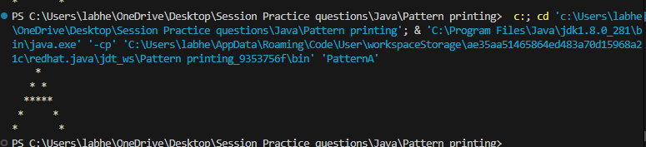

1. **Code-B:**

//Pattern B

public class PatternB {

public static void main(String[] args) {

int n = 7;

for (int i = 0; i < n; i++) {

for (int j = 0; j < n; j++) {

if (j == 0) {

System.out.print("*");

}

else if ((i == 0 || i == n - 1 || i == n / 2) && j < n - 1) {

System.out.print("*");

} else if (j == n - 1 && (i != 0 && i < n / 2)) {

System.out.print("*");

}

else if (j == n - 1 && (i > n / 2 && i != n - 1)) {

System.out.print("*");

} else {

System.out.print(" ");

}

}

System.out.println();

}

}

}

O/P:

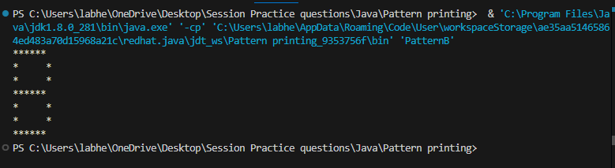

1. **Code-C:**

// Pattern C

public class PatternC {

public static void main(String[] args) {

int n = 7;

for (int i = 0; i < n; i++) {

for (int j = 0; j < n; j++) {

if (i == 0 && j > 0 ||

i == n - 1 && j > 0 ||

j == 0 && i > 0 && i < n - 1) {

System.out.print("*");

}

else {

System.out.print(" ");

}

}

System.out.println();

}

}

}

O/P:

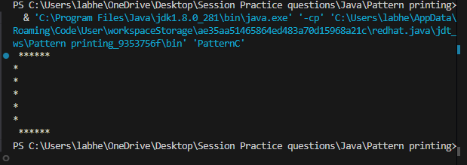

1. **Code-D:**

//Pattern D

public class PatternD {

public static void main(String[] args) {

int n = 7;

for (int i = 0; i < n; i++) {

for (int j = 0; j < n - 1; j++) {

if (j == 0 ||

(i == 0 || i == n - 1) && j < n - 2 ||

j == n - 2 && i != 0 && i != n - 1) {

System.out.print("*");

} else {

System.out.print(" ");

}

}

System.out.println();

}

}

}

O/P:

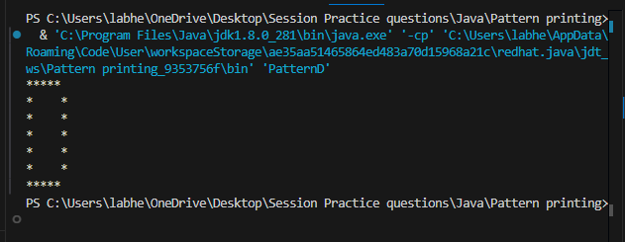

1. **Code-E:**

//pattern E

public class PatternE {

public static void main(String[] args) {

int n = 7;

for (int i = 0; i < n; i++) {

for (int j = 0; j < n; j++) {

if (j == 0 ||

i == 0 ||

i == n - 1 ||

i == n / 2) {

System.out.print("*");

} else {

System.out.print(" ");

}

}

System.out.println();

}

}

}

O/P:

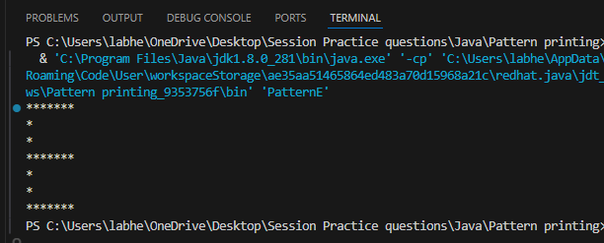

1. **Code-F:**

//pattern F

public class PatternF {

public static void main(String[] args) {

int n = 7;

for (int i = 0; i < n; i++) {

for (int j = 0; j < n; j++) {

if (j == 0 || i == 0 || i == n / 2)

System.out.print("*");

else

System.out.print(" ");

}

System.out.println();

}

}

}

O/P:

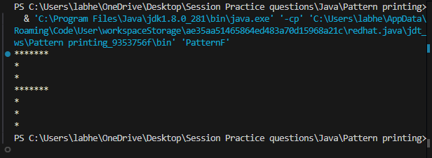

1. **Code-G:**

//Pattern G

public class PatternG {

public static void main(String[] args) {

int n = 7;

for (int i = 0; i < n; i++) {

for (int j = 0; j < n; j++) {

if (i == 0 && j > 0 ||

i == n - 1 && j > 0 ||

j == 0 && i > 0 && i < n - 1 ||

i == n / 2 && j >= n / 2 ||

j == n - 1 && i >= n / 2)

System.out.print("*");

else

System.out.print(" ");

}

System.out.println();

}

}

}

O/P:

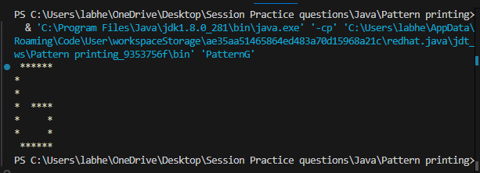

1. **Code-H:**

//Pattern H

public class PatternH {

public static void main(String[] args) {

int n = 7;

for (int i = 0; i < n; i++) {

for (int j = 0; j < n; j++) {

if (j == 0 || j == n - 1 || i == n / 2)

System.out.print("*");

else

System.out.print(" ");

}

System.out.println();

}

}

}

O/P:

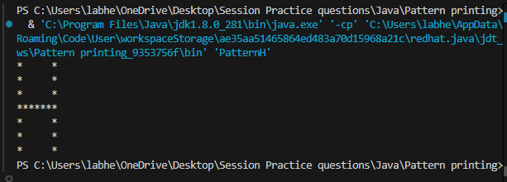

1. **Code-I:**

//Pattern I

public class PatternI {

public static void main(String[] args) {

int n = 7;

for (int i = 0; i < n; i++) {

for (int j = 0; j < n; j++) {

if (i == 0 || i == n - 1 || j == n / 2)

System.out.print("*");

else

System.out.print(" ");

}

System.out.println();

}

}

}

O/P:

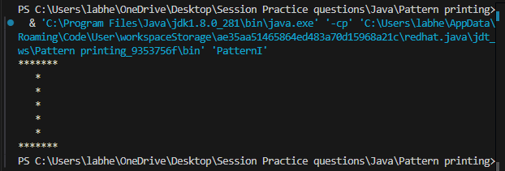

1. **Code-J:**

//Pattern J

public class PatternJ {

public static void main(String[] args) {

int n = 7;

for (int i = 0; i < n; i++) {

for (int j = 0; j < n; j++) {

if ((i != n - 1 && j == n - 1) || (i == n - 1 && j > 0 && j < n - 1)

|| (i >= n / 2 && i != n - 1 && j == 0)) {

System.out.print("*");

} else {

System.out.print(" ");

}

}

System.out.println();

}

}

}

O/P:

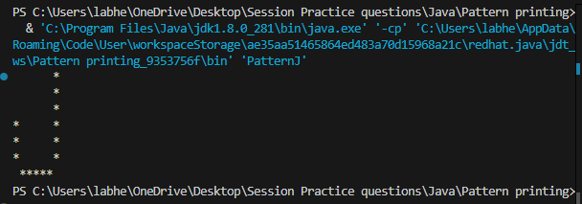

1. **Code-K:**

//Pattern K

public class PatternK {

public static void main(String[] args) {

int n = 7;

for (int i = 0, j, k = n / 2; i < n; i++) {

for (j = 0; j < n; j++) {

if (j == 0 || j == k)

System.out.print("*");

else

System.out.print(" ");

}

if (i < n / 2)

k--;

else

k++;

System.out.println();

}

}

}

O/P:

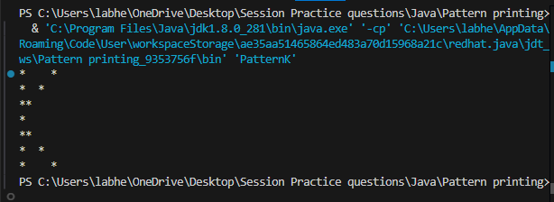

1. **Code-L:**

//Pattern L

public class PatternL {

public static void main(String[] args) {

int n = 7;

for (int i = 0; i < n; i++) {

for (int j = 0; j < n; j++) {

if (j == 0 || i == n - 1) {

System.out.print("*");

}

else {

System.out.print(" ");

}

}

System.out.println();

}

}

}

O/P:

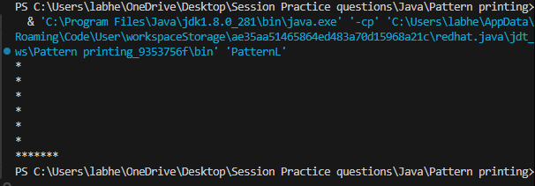

1. **Code-M:**

//Pattern M

public class PatternM {

public static void main(String[] args) {

int n = 7;

for (int i = 0; i < n; i++) {

for (int j = 0; j < n; j++) {

if (j == 0 || j == n - 1 || (i == j && i <= n / 2) || (i + j == n - 1 && i <= n / 2)) {

System.out.print("*");

}

else{

System.out.print(" ");

}

}

System.out.println();

}

}

}

O/P:

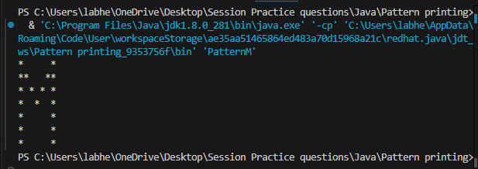

1. **Code-N:**

//Pattern N

public class PatternN {

public static void main(String[] args) {

int n = 7;

for (int i = 0; i < n; i++) {

for (int j = 0; j < n; j++) {

if (j == 0 || j == n - 1 || i == j)

{

System.out.print("*");

}

else

{

System.out.print(" ");

}

}

System.out.println();

}

}

}

O/P:

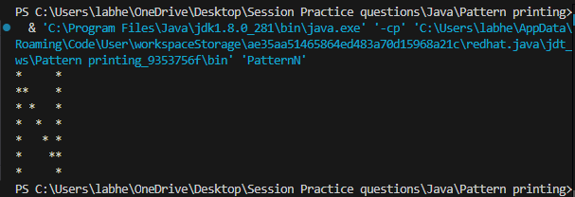

1. **Code-O:**

//Pattern O

public class PatternO {

public static void main(String[] args) {

int n = 7;

for (int i = 0; i < n; i++) {

for (int j = 0; j < n; j++) {

if ((i == 0 || i == n - 1) && j > 0 && j < n - 1 ||

(j == 0 || j == n - 1) && i > 0 && i < n - 1)

{

System.out.print("*");

}

else

{

System.out.print(" ");

}

}

System.out.println();

}

}

}

O/P:

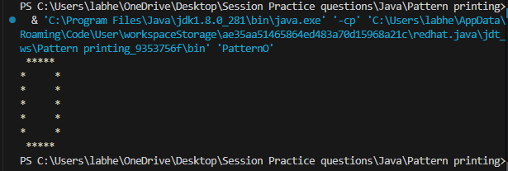

1. **Code-P:**

//Pattern P

public class PatternP {

public static void main(String[] args) {

int n = 7;

for (int i = 0; i < n; i++) {

for (int j = 0; j < n; j++) {

if (j == 0 || (i == 0 || i == n / 2) && j < n - 1 || j == n - 1 && i > 0 && i < n / 2)

{

System.out.print("*");

}

else

{

System.out.print(" ");

}

}

System.out.println();

}

}

}

O/P:

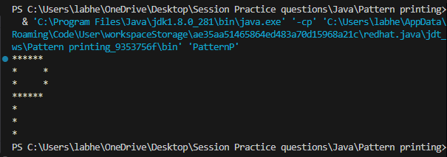

1. **Code-Q:**

//Pattern Q

public class PatternQ {

public static void main(String[] args) {

int n = 7;

for (int i = 0; i < n; i++) {

for (int j = 0; j < n; j++) {

if ((i == 0 || i == n - 2) && j > 0 && j < n - 1 ||

(j == 0 || j == n - 1) && i > 0 && i < n - 2 ||

(i == j && i >= n / 2))

{

System.out.print("*");

}

else

{

System.out.print(" ");

}

}

System.out.println();

}

}

}

O/P:

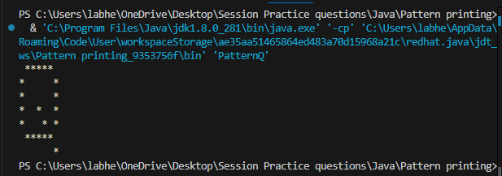

1. **Code-R:**

//Pattern R

public class PatternR {

public static void main(String[] args) {

int n = 7;

for (int i = 0; i < n; i++) {

for (int j = 0; j < n; j++) {

if (j == 0 || (i == 0 || i == n / 2) && j < n - 1 ||

j == n - 1 && i > 0 && i < n / 2 || i - j == n / 2)

{

System.out.print("*");

}

else

{

System.out.print(" ");

}

}

System.out.println();

}

}

}

O/P:

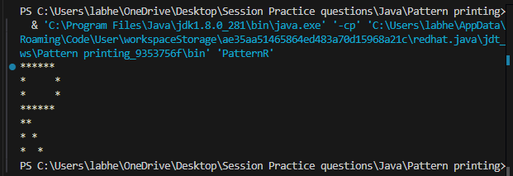

1. **Code-S:**

//Pattern S

public class PatternS {

public static void main(String[] args) {

int n = 7;

for (int i = 0; i < n; i++) {

for (int j = 0; j < n; j++) {

if (i == 0 && j > 0 ||

i == n / 2 && j < n - 1 ||

i == n - 1 && j < n - 1 ||

j == 0 && i > 0 && i < n / 2 ||

j == n - 1 && i > n / 2 && i < n - 1)

{

System.out.print("*");

}

else

{

System.out.print(" ");

}

}

System.out.println();

}

}

}

O/P:

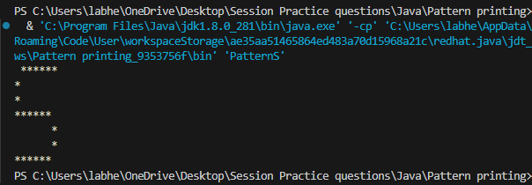

1. **Code-T:**

//Pattern T

public class PatternT {

public static void main(String[] args) {

int n = 7;

for (int i = 0; i < n; i++) {

for (int j = 0; j < n; j++) {

if (i == 0 || j == n / 2)

{

System.out.print("*");

}

else

{

System.out.print(" ");

}

}

System.out.println();

}

}

}

O/P:

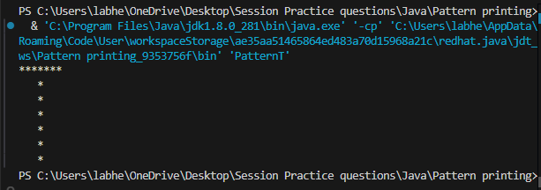

1. **Code-U:**

//Pattern U

public class PatternU {

public static void main(String[] args) {

int n = 7;

for (int i = 0; i < n; i++) {

for (int j = 0; j < n; j++) {

if ((j == 0 || j == n - 1) && i != n - 1 ||

i == n - 1 && j > 0 && j < n - 1)

{

System.out.print("*");

}

else

{

System.out.print(" ");

}

}

System.out.println();

}

}

}

O/P:

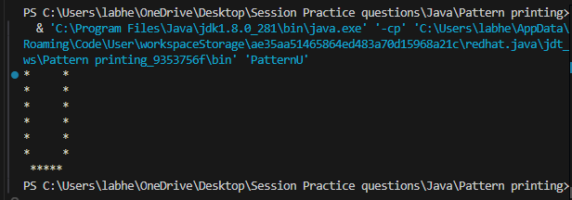

1. **Code-V:**

//Pattern V

public class patternV {

public static void main(String[] args) {

int n = 7;

for (int i = 0; i < n; i++) {

for (int j = 0; j < n * 2 - 1; j++) {

if (j == i || j == 2 * n - 2 - i)

{

System.out.print("*");

}

else

{

System.out.print(" ");

}

}

System.out.println();

}

}

}

O/P:

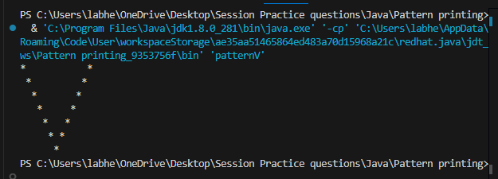

1. **Code-W:**

//Pattern W

public class patternW {

public static void main(String[] args) {

int n = 7;

for (int i = 0; i < n; i++) {

for (int j = 0; j < n; j++) {

if (j == 0 || j == n - 1 || (i >= n / 2 && (j == i || j == n - i - 1))) {

System.out.print("*");

} else {

System.out.print(" ");

}

}

System.out.println();

}

}

}

O/P:

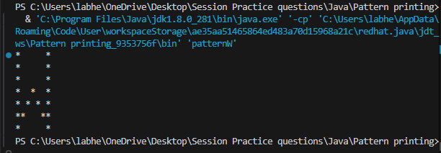

1. **Code-X:**

//Pattern X

public class PatternX {

public static void main(String[] args) {

int n = 7;

for (int i = 0; i < n; i++) {

for (int j = 0; j < n; j++) {

if (i == j || i + j == n - 1)

{

System.out.print("*");

}

else

{

System.out.print(" ");

}

}

System.out.println();

}

}

}

O/P:

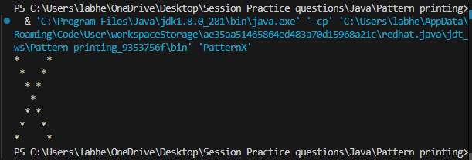

1. **Code-Y:**

//Pattern Y

public class PatternY {

public static void main(String[] args) {

int n = 7;

for (int i = 0; i < n; i++) {

for (int j = 0; j < n; j++) {

if (i == j && i < n / 2 ||

i + j == n - 1 && i < n / 2 ||

j == n / 2 && i >= n / 2)

{

System.out.print("*");

}

else

{

System.out.print(" ");

}

}

System.out.println();

}

}

}

O/P:

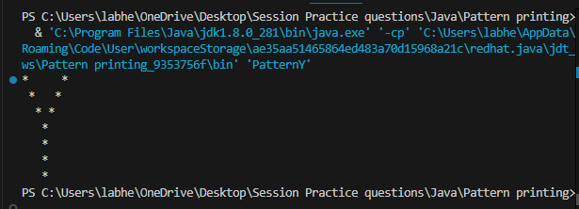

1. **Code-Z:**

//pattern Z

public class PatternZ {

public static void main(String[] args) {

int n = 7;

for (int i = 0; i < n; i++) {

for (int j = 0; j < n; j++) {

if (i == 0 || i == n - 1 || i + j == n - 1)

{

System.out.print("*");

}

else

{

System.out.print(" ");

}

}

System.out.println();

}

}

}

O/P:

